Week 11

Implementation of IT Audit, malware analysis and Vulnerability assessment and generate the report.

Aim:- To perform an IT audit, analyze malware, identify system vulnerabilities, and generate a security assessment report.
Input:-
- Malware File
- Nmap Tool
- Virustotal
- Filescan.io

Step1:
Download malware (https://github.com/rampriyakilari/ICS-Needs/blob/main/malware.rar)

Step2:
Basic Information about malware:
Name: file.exe
Media Type: application/x-msdownload
SHA-256: d01d08621690c1a7a0f41bdd1bb02ec05d418ef68b06cd3cfd54fbb3f58ba80a Report ID: 37cec6e6-0778-4c35-9cb3-d177c1e6e34a
Submission Date: 29/09/2026, 02:24:27

Step3:Malware Analysis

Report from filescan.io
In filescan.io

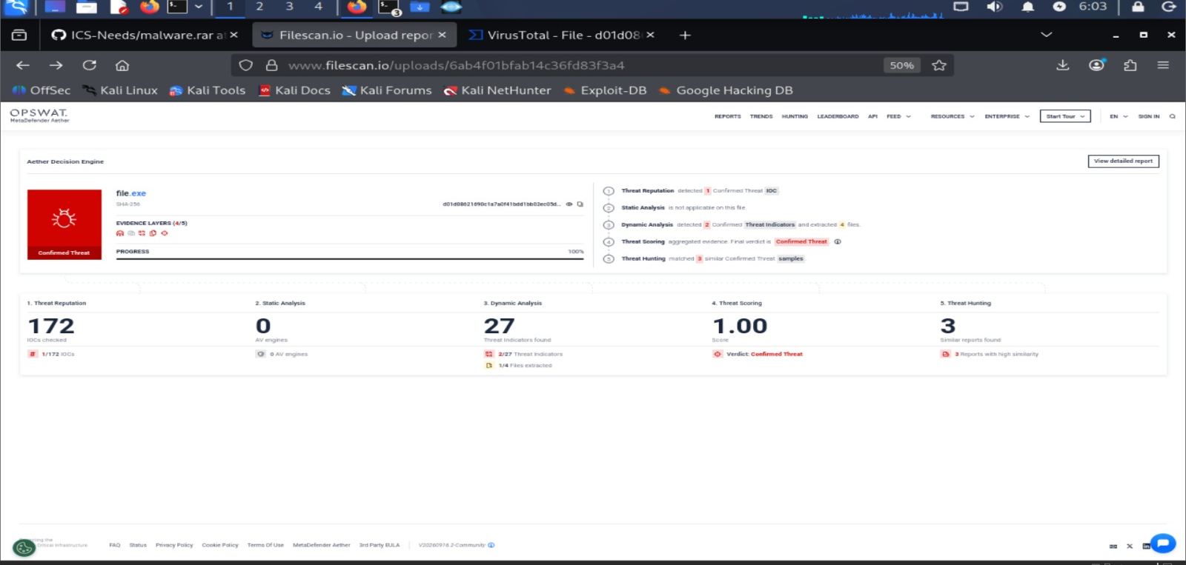
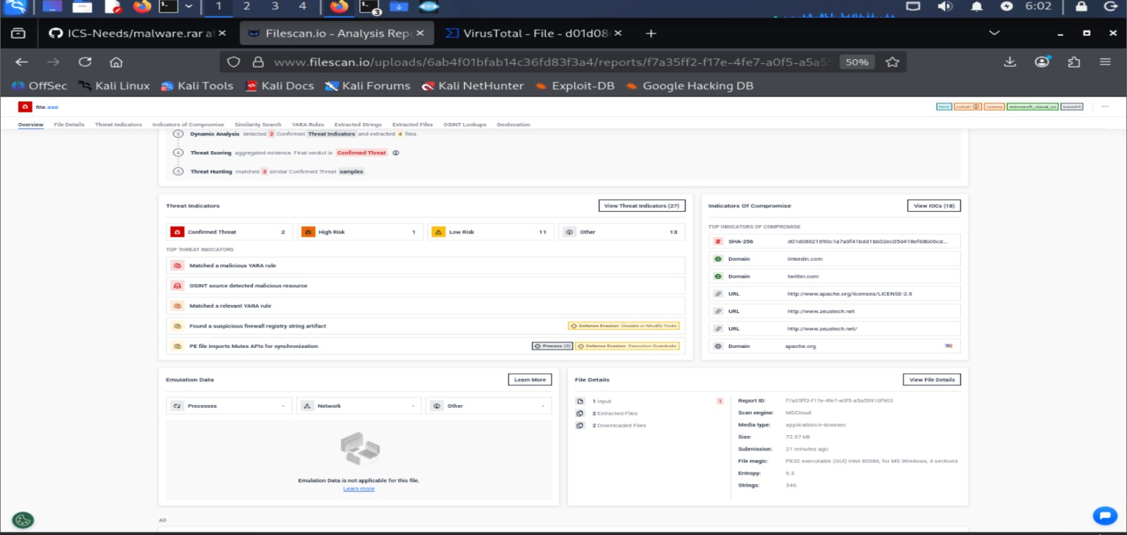

Report in virustotal

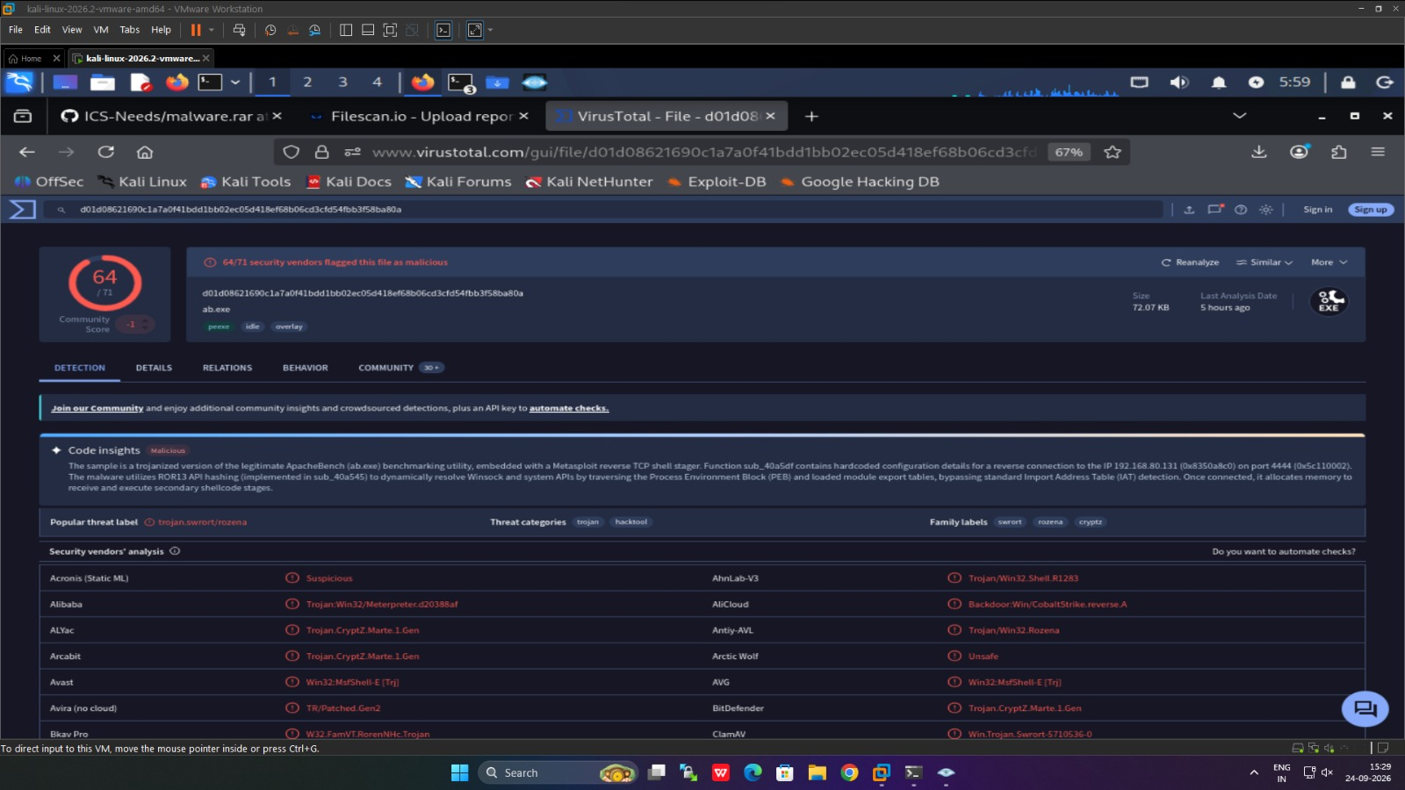

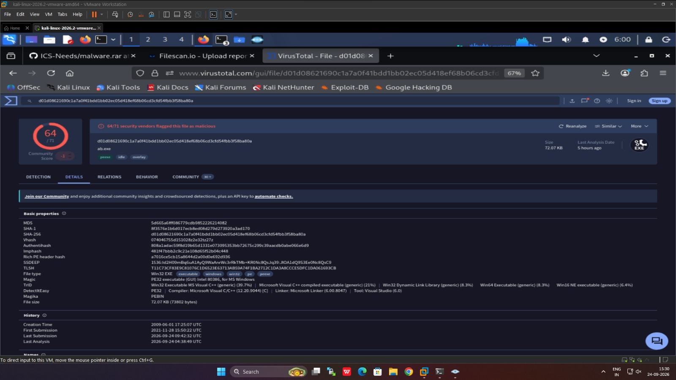

Step 4:-
Vulnerability Assessment
Report in Kali using Nmap tool
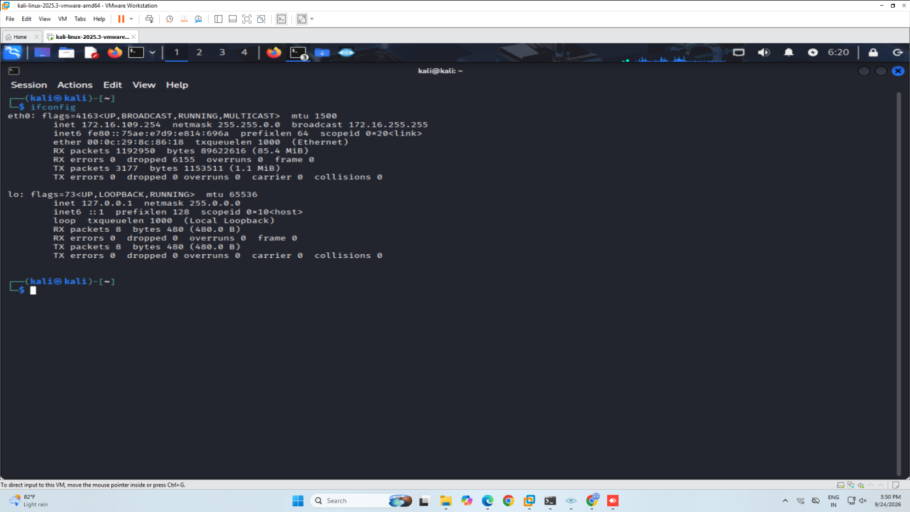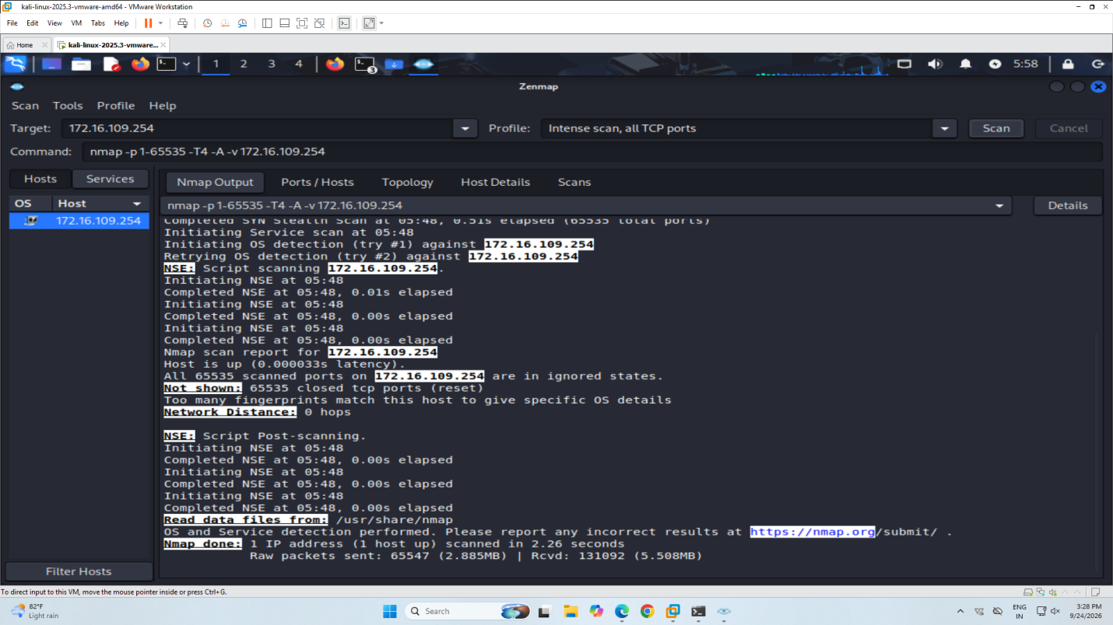

Report in Windows using Nmap tool
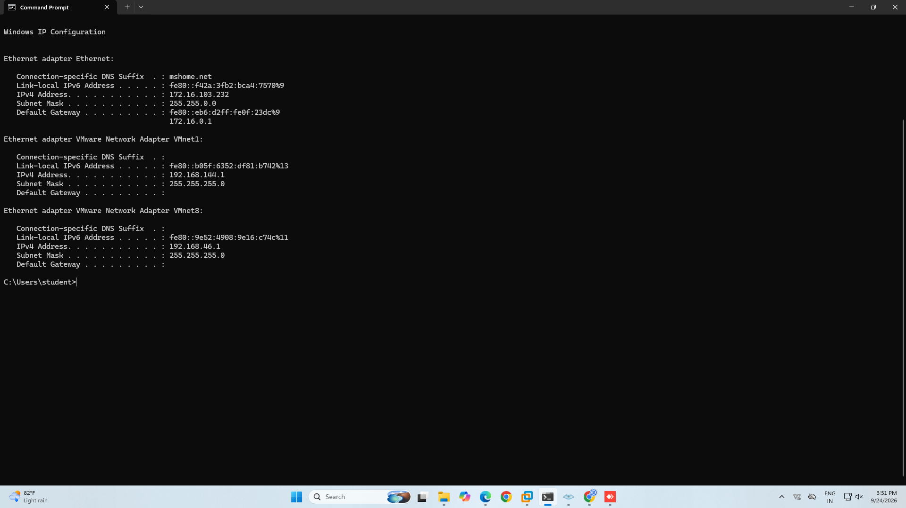

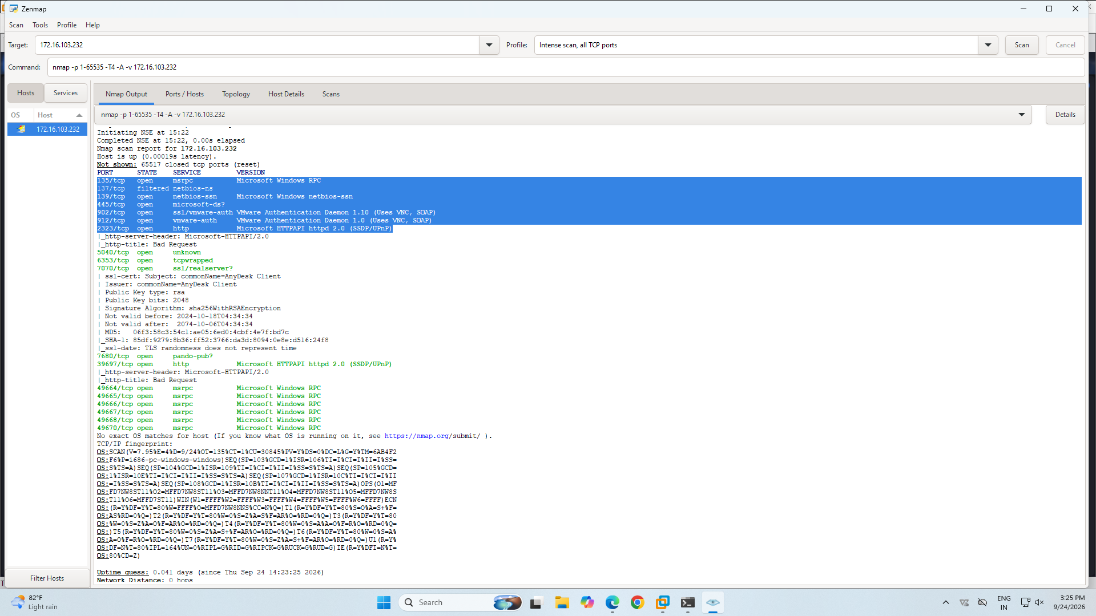

Final deduction

Final report.

IT Audit: Do the port scanning of the computer using nmap/zenmap to identify the open ports and see if services running on those ports are vulnerable or not. Write a report on it.

Result:- The IT audit, malware analysis, and vulnerability assessment were successfully performed, and a final security assessment report was generated.

